**Cluneal Nerve Entrapment: Clinical Presentation and Physical Therapy Interventions**

**Introduction**

Cluneal nerve entrapment is a medical condition where cluneal nerve compression causes pain and discomfort in the bottom and lowest back. The cluneal nerves are crucial sensory nerves that supply sensations to the pelvic and low back regions. There are two main types: the superior cluneal nerves (SCNs) and the inferior cluneal nerves (ICNs). While ICNs come from the sacral nerves (S1-S3), SCNs are derived from the dorsal rami of the upper lumbar and lower thoracic spinal nerves (T10-L4). These nerves are a vital part in the transmission of sensory information like pain and temperature to the brain[1]. These nerves are also essential to human body as they help individuals perceive and respond to different stimuli from the environment thus contribute to sensory awareness and bodily functions.

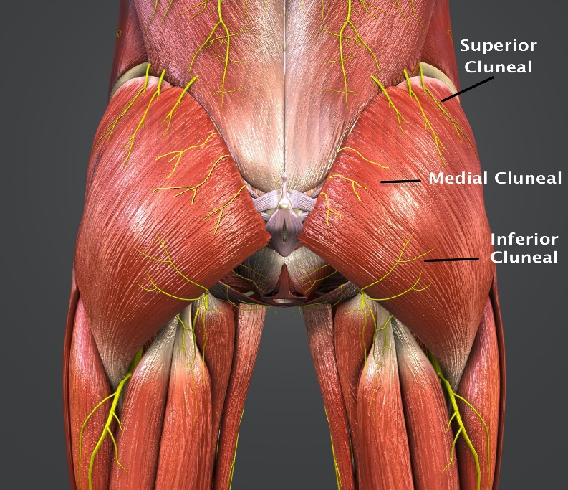

**Possible Causes for Entrapment**

Cluneal nerve entrapment is a condition that most likely occurs when some nerves in the back that are close to the spine are compressed which leads to the sensation and pain. This condition may be affected by various factors, which mainly include anatomic variations but some individuals who show unique pelvic bone structures or nerve pathways may become more susceptible to this type of nerve compression[2]. This may occur when differences in how the pelvic bones are aligned or variations in the path a nerve takes can significantly affect the likelihood of entrapment. Such structural differences increase the risk for nerve compression and, ultimately, pain and dysfunction.

In addition to this, there are also traumas and lifestyle or job related actions that can contribute to cluneal nerve entrapment. Traumatic incidents, such as impact injuries to the lower back, can cause inflammation or direct damage to the nerves increasing the chances for entrapment. These kind of injuries might not affect the nerves immediately but they can result in long-term issues or illnesses if the initial inflammation or damage occurred disrupted the normal function of the nerve[3]. Moreover, keeping a posture in a single position for a long time like sitting or standing in the same position can significantly increase the pressure on the cluneal nerves[4]. Similarly, doing the same movement repeatedly such as performing certain sports as in the case of athletes or occupational tasks can continuously stress the nerves, potentially leading to chronic pain and nerve issues over time[5].

**Clinical Presentation**

Patients who suffer from the clunel nerve entrapment frequently experience characteristic symptoms, such as pain in the lower part of the back and the buttocks which can be felt on one or both sides of the body. The pain usually comes up as sharp, burning or shooting, it can reach downward to the buttock, the back of the leg, or even the groin area, making the activities of daily living difficult and reducing the quality of the life[6]. During medical examinations, the areas affected by the pain might also be particularly tender to touch, indicating the regions where the nerve might be compressed or irritated.

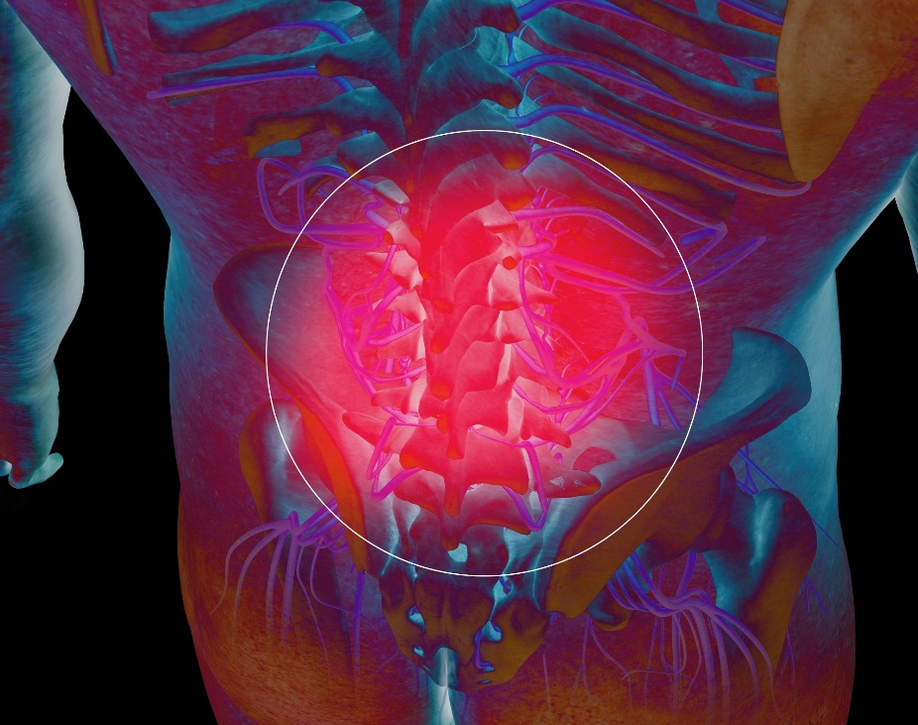

Middle Cluneal Nerve Entrapment Before Surgery

Alongside the pain and the feeling of tenderness, the patients would also report abnormalities in their skin sensation, such as sensitivity increase in some areas and a decrease in others, which demonstrates the nerve involvement[7]. Symptoms more commonly exacerbate during sitting, standing, and physical activity for prolonged periods and it often interferes the patients' day to day routine activities or they may even find it difficult to complete simple tasks. The persistent discomfort can greatly affect their well-being, thus, the need for correct diagnosis and treatment options to resolve these symptoms is crucial so that patients may recover from the debilitating effects of this illness and resume their daily routines[8].

**Diagnostic Testing**

To ensure accurate diagnosis of the cluneal nerve entrapment, several different tests exist. For one approach take the nerve block in which a doctor injects a medicine that anesthetized the nerve. If the patient experiences a relief from pain in the area after this injection, this suggests that the cluneal nerve is the most probable source of the pain[9]. Another technique is electromyography (EMG) and nerve conduction studies. These tests identify the level of nerve activity and look at whether it is functioning well. If the results identify an abnormal electrical activity within cluneal nerve, it shows that the nerve is damaged[10].

Another method which is also helpful in diagnosis of this condition is the use of the ultrasound images[11]. It allows doctors to see the nerve's path and check for any physical abnormalities that might be pressing on the nerve. Ultrasound can also help guide the doctor during a nerve block procedure to ensure accuracy. It allows doctors to see the nerve's path and check for any physical abnormalities that might be pressing on the nerve. Ultrasound can also help guide the doctor during a nerve block procedure to ensure accuracy.

**Differential Diagnosis:**

Identifying cluneal nerve entrapment from other conditions that affect the lower back and buttocks is important because their symptoms often overlap. For example, lumbar radiculopathy also causes pain in these areas, but it comes from pressure on nerve roots in the spine. This can be seen on MRI or CT scans, which help doctors see where the nerve is being squeezed[12].

Piriformis syndrome is another condition that can look like cluneal nerve entrapment because it causes sciatic-like pain. Doctors use special physical tests, such as the Freiberg and Pace tests, to check if the piriformis muscle is the problem[13].

Sacroiliac joint dysfunction can also cause similar pain. Doctors might use injections to test for this problem or do physical tests like the FABER test to see how the sacroiliac joint is working[14]. These diagnostic approaches are essential for accurate identification and effective management of these conditions.

**Physical Therapy Interventions**

Physical therapy interventions is important when it comes to the management of cluneal nerve entrapment since it aims at pain reduction, restoration of function, and prevention of relapse. The use of therapeutic methods such as soft-tissue mobilization, myofascial lengthening and stretching can work to reduce muscular tension, release fascias in the correct way and to move the nerves properly. The use of these methods, for example, in the lower back and hips area has been proven to alleviate the pressure on the nerves[15]. Furthermore, a mixed exercise program which comprises of core, hips and lower back strength training is important. This program should include exercises such as bridges, clamshells and bird dogs that are meant to stabilize the lower back and hips, thus reducing the pressure on the cluneal nerve and improving the overall body mechanics[16].

Cupping therapy is also a treatment that can be effective for conditions of cluneal nerve entrapment. This technique involves placing cups on the skin to create suction, which increases blood flow to the area[17]. Improved blood circulation can help relax the muscles in the lower back, which might be compressing the cluneal nerve. By reducing muscle tension in this way, cupping can help alleviate the symptoms associated with nerve entrapment, such as pain and discomfort in the lower back and buttocks. The relief provided by cupping can make it a useful supplement to more traditional physical therapy methods aimed at reducing nerve pressure (Chen et al., 2017).

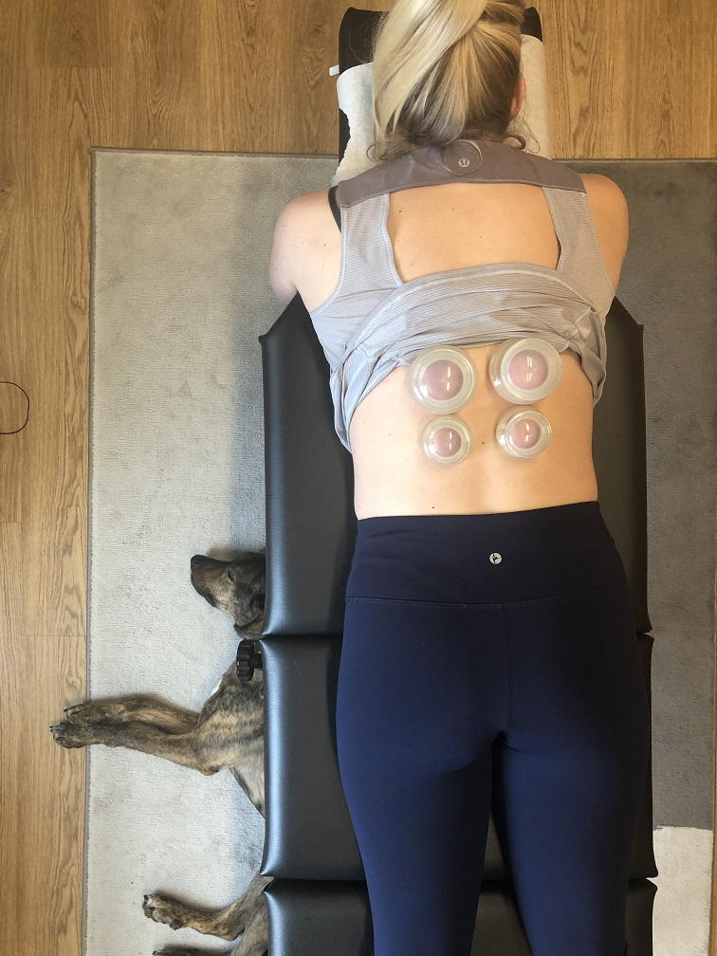

Different types of treatment such as hot, ice or electrical stimulation and massages can also work in suppressing pain and for encouragement of tissue healing, yet, they should not be considered as the ultimate treatment, but rather be part of a total plan and not the primary treatment[18]. Along with their ongoing treatment, it is equally significant for patients to also begin to resume their normal way of life while attending to the therapeutic activities that they enjoy as well. But in the meantime they must exercise caution to not take up activities that can further cause pain. This cautious approach of increasing the activity levels is very effective as it keeps a close eye on whether the symptoms are steadily improving and thus prevents the problem from coming back and helping patients maintain their independence[19]. Together, these strategies ensure that treatments support long-term improvement and help patients return to a normal, active life without constant discomfort.

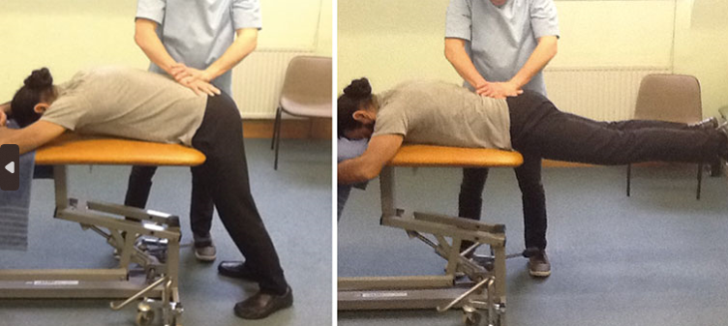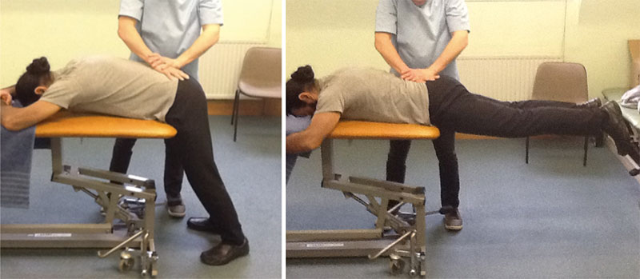Top of Form

**ConclusionTop of Form**

Cluneal nerve entrapment impacts people significantly as they will have continued and persistent pain in the lower back and the buttocks, which affects their overall quality of life. An understanding of this problem and anatomy, how the illness presents itself clinically, the causes of the nerve entrapment, and effective physical therapy interventions are essential for effective management. According to studies, physical therapy management is crucial in identifying and addressing the factors that contribute to the condition, relieving pain, and helping restore normal function of individuals affected by this condition[20]. With their techniques of applying different approaches like stretching, exercise programs to strengthen muscles, massage and education on proper posture to avoid increasing pain, their role is important in managing this problem.

**Bibliography**

Jun, J., Oh, J., & Park, D. (2021). Superior Cluneal Nerve Entrapment as Uncommon Cause of Buttock Pain. *International Journal of Pain*, *12*(1), 15–18. <https://doi.org/10.56718/ijp.20-010>

2 Konno, T., Aota, Y., Saito, T., Qu, N., Hayashi, S., Kawata, S., & Itoh, M. (2017). Anatomical study of middle cluneal nerve entrapment. Journal of Pain Research, Volume 10, 1431–1435. <https://doi.org/10.2147/jpr.s135382>

3 Koçak, F. A. (2020). Superior cluneal nerve entrapment neuropathy due to lower crossed syndrome: A case with low back pain. Ağrı - the Journal of the Turkish Society of Algology. https://doi.org/10.14744/agri.2020.21703

4 Anderson, D., Szarvas, D., Koontz, C., Hebert, J., Li, N., Hasoon, J., Viswanath, O., Kaye, A. D., & Urits, I. (2022). A Comprehensive Review of Cluneal Neuralgia as a Cause of Lower Back Pain. *Orthopedic Reviews*, *14*(3). https://doi.org/10.52965/001c.35505

5 Aldridge, J. W., Bruno, R. J., Strauch, R. J., & Rosenwasser, M. P. (2001). Nerve Entrapment in Athletes. Clinics in Sports Medicine, 20(1), 95–122. https://doi.org/10.1016/s0278-5919(05)70249-0

6 Anderson, D., Szarvas, D., Koontz, C., Hebert, J., Li, N., Hasoon, J., Viswanath, O., Kaye, A. D., & Urits, I. (2022). A Comprehensive Review of Cluneal Neuralgia as a Cause of Lower Back Pain. Orthopedic Reviews, 14(3). https://doi.org/10.52965/001c.35505

7 Koçak, F. A. (2020). Superior cluneal nerve entrapment neuropathy due to lower crossed syndrome: A case with low back pain. Ağrı - the Journal of the Turkish Society of Algology.

8 Konno, T., Aota, Y., Saito, T., Qu, N., Hayashi, S., Kawata, S., & Itoh, M. (2017). Anatomical study of middle cluneal nerve entrapment. Journal of Pain Research, Volume 10, 1431–1435.

9 Wu, W.-T., Kamal Mezian, Ondřej Naňka, Chen, L.-R., Ricci, V., Lin, C.-P., Chang, K.-V., & Levent Özçakar. (2023). Enhancing diagnosis and treatment of superior cluneal nerve entrapment: cadaveric, clinical, and ultrasonographic insights. Insights into Imaging, 14(1). https://doi.org/10.1186/s13244-023-01463-0

10 Hameer Thatte, & Orlando De Jesus. (2021, October 9). Electrodiagnostic Evaluation Of Peroneal Neuropathy. Nih.gov; StatPearls Publishing. https://www.ncbi.nlm.nih.gov/books/NBK563251/

11 Wu, W.-T., Mezian, K., Nanka, O., Chang, K.-V., & Ozcakar, L. (2022). Ultrasonographic Imaging and Guided Intervention for the Superior Cluneal Nerve: A Narrative Pictorial Review. *Pain Physician*, *25*(4), E657–E667. https://pubmed.ncbi.nlm.nih.gov/35793190/

12 Anderson, D., Szarvas, D., Koontz, C., Hebert, J., Li, N., Hasoon, J., Viswanath, O., Kaye, A. D., & Urits, I. (2022). A Comprehensive Review of Cluneal Neuralgia as a Cause of Lower Back Pain. *Orthopedic Reviews*, *14*(3). https://doi.org/10.52965/001c.35505

13 Hicks, B. L., Lam, J. C., & Varacallo, M. (2020). *Piriformis Syndrome*. PubMed; StatPearls Publishing. https://www.ncbi.nlm.nih.gov/books/NBK448172/

14 Matsumoto, J., Isu, T., Kim, K., Miki, K., Fujihara, F., & Isobe, M. (2019). Middle cluneal nerve entrapment mimics sacroiliac joint pain. *Acta Neurochirurgica*, *161*(4), 657–661. https://doi.org/10.1007/s00701-019-03861-0

15 Paracha, U., & Hendrix, J. M. (2023). Cluneal Neuralgia. PubMed; StatPearls Publishing. https://www.ncbi.nlm.nih.gov/books/NBK587348/

16 Cho, I., Jeon, C., Lee, S., Lee, D., & Hwangbo, G. (2015). Effects of lumbar stabilization exercise on functional disability and lumbar lordosis angle in patients with chronic low back pain. Journal of Physical Therapy Science, 27(6), 1983–1985. https://doi.org/10.1589/jpts.27.1983

17 Cao, H., Li, X., & Liu, J. (2012). An Updated Review of the Efficacy of Cupping Therapy. PLoS ONE, 7(2), e31793. https://doi.org/10.1371/journal.pone.0031793

18 Ruan, T., & Jones, A. C. (2023). Superior Cluneal Nerve Entrapment Syndrome: Thought to Be Spondylolysis. Journal of the American Academy of Orthopaedic Surgeons. Global Research & Reviews, 7(10), e23.00091. https://doi.org/10.5435/JAAOSGlobal-D-23-00091

19Anderson, D., Szarvas, D., Koontz, C., Hebert, J., Li, N., Hasoon, J., Viswanath, O., Kaye, A. D., & Urits, I. (2022). A Comprehensive Review of Cluneal Neuralgia as a Cause of Lower Back Pain. *Orthopedic Reviews*, *14*(3). https://doi.org/10.52965/001c.35505

20 Inklebarger, James & Galanis, Nikiforos. (2024). The Management of Cluneal Nerve Referred Pain with Prolotherapy. 1. e982-e991.

1. Jun, J., Oh, J., & Park, D. (2021). Superior Cluneal Nerve Entrapment as Uncommon Cause of Buttock Pain. *International Journal of Pain*, *12*(1), 15–18. <https://doi.org/10.56718/ijp.20-010>
2. Konno, T., Aota, Y., Saito, T., Qu, N., Hayashi, S., Kawata, S., & Itoh, M. (2017). Anatomical study of middle cluneal nerve entrapment. Journal of Pain Research, Volume 10, 1431–1435. https://doi.org/10.2147/jpr.s135382
3. Koçak, F. A. (2020). Superior cluneal nerve entrapment neuropathy due to lower crossed syndrome: A case with low back pain. Ağrı - the Journal of the Turkish Society of Algology. https://doi.org/10.14744/agri.2020.21703
4. Anderson, D., Szarvas, D., Koontz, C., Hebert, J., Li, N., Hasoon, J., Viswanath, O., Kaye, A. D., & Urits, I. (2022). A Comprehensive Review of Cluneal Neuralgia as a Cause of Lower Back Pain. *Orthopedic Reviews*, *14*(3). https://doi.org/10.52965/001c.35505
5. Aldridge, J. W., Bruno, R. J., Strauch, R. J., & Rosenwasser, M. P. (2001). Nerve Entrapment in Athletes. Clinics in Sports Medicine, 20(1), 95–122. https://doi.org/10.1016/s0278-5919(05)70249-0
6. Anderson, D., Szarvas, D., Koontz, C., Hebert, J., Li, N., Hasoon, J., Viswanath, O., Kaye, A. D., & Urits, I. (2022). A Comprehensive Review of Cluneal Neuralgia as a Cause of Lower Back Pain. Orthopedic Reviews, 14(3). https://doi.org/10.52965/001c.35505
7. Koçak, F. A. (2020). Superior cluneal nerve entrapment neuropathy due to lower crossed syndrome: A case with low back pain. Ağrı - the Journal of the Turkish Society of Algology.
8. Konno, T., Aota, Y., Saito, T., Qu, N., Hayashi, S., Kawata, S., & Itoh, M. (2017). Anatomical study of middle cluneal nerve entrapment. Journal of Pain Research, Volume 10, 1431–1435.
9. Wu, W.-T., Kamal Mezian, Ondřej Naňka, Chen, L.-R., Ricci, V., Lin, C.-P., Chang, K.-V., & Levent Özçakar. (2023). Enhancing diagnosis and treatment of superior cluneal nerve entrapment: cadaveric, clinical, and ultrasonographic insights. Insights into Imaging, 14(1). https://doi.org/10.1186/s13244-023-01463-0

   ‌
10. Hameer Thatte, & Orlando De Jesus. (2021, October 9). Electrodiagnostic Evaluation Of Peroneal Neuropathy. Nih.gov; StatPearls Publishing. https://www.ncbi.nlm.nih.gov/books/NBK563251/
11. Wu, W.-T., Mezian, K., Nanka, O., Chang, K.-V., & Ozcakar, L. (2022). Ultrasonographic Imaging and Guided Intervention for the Superior Cluneal Nerve: A Narrative Pictorial Review. *Pain Physician*, *25*(4), E657–E667. https://pubmed.ncbi.nlm.nih.gov/35793190/
12. Anderson, D., Szarvas, D., Koontz, C., Hebert, J., Li, N., Hasoon, J., Viswanath, O., Kaye, A. D., & Urits, I. (2022). A Comprehensive Review of Cluneal Neuralgia as a Cause of Lower Back Pain. *Orthopedic Reviews*, *14*(3). https://doi.org/10.52965/001c.35505
13. Hicks, B. L., Lam, J. C., & Varacallo, M. (2020). *Piriformis Syndrome*. PubMed; StatPearls Publishing. https://www.ncbi.nlm.nih.gov/books/NBK448172/
14. Matsumoto, J., Isu, T., Kim, K., Miki, K., Fujihara, F., & Isobe, M. (2019). Middle cluneal nerve entrapment mimics sacroiliac joint pain. *Acta Neurochirurgica*, *161*(4), 657–661. https://doi.org/10.1007/s00701-019-03861-0
15. Paracha, U., & Hendrix, J. M. (2023). Cluneal Neuralgia. PubMed; StatPearls Publishing. https://www.ncbi.nlm.nih.gov/books/NBK587348/
16. Cho, I., Jeon, C., Lee, S., Lee, D., & Hwangbo, G. (2015). Effects of lumbar stabilization exercise on functional disability and lumbar lordosis angle in patients with chronic low back pain. Journal of Physical Therapy Science, 27(6), 1983–1985. https://doi.org/10.1589/jpts.27.1983
17. Cao, H., Li, X., & Liu, J. (2012). An Updated Review of the Efficacy of Cupping Therapy. PLoS ONE, 7(2), e31793. https://doi.org/10.1371/journal.pone.0031793
18. Ruan, T., & Jones, A. C. (2023). Superior Cluneal Nerve Entrapment Syndrome: Thought to Be Spondylolysis. Journal of the American Academy of Orthopaedic Surgeons. Global Research & Reviews, 7(10), e23.00091. https://doi.org/10.5435/JAAOSGlobal-D-23-00091

    ‌
19. Anderson, D., Szarvas, D., Koontz, C., Hebert, J., Li, N., Hasoon, J., Viswanath, O., Kaye, A. D., & Urits, I. (2022). A Comprehensive Review of Cluneal Neuralgia as a Cause of Lower Back Pain. *Orthopedic Reviews*, *14*(3). https://doi.org/10.52965/001c.35505
20. Inklebarger, James & Galanis, Nikiforos. (2024). The Management of Cluneal Nerve Referred Pain with Prolotherapy. 1. e982-e991.